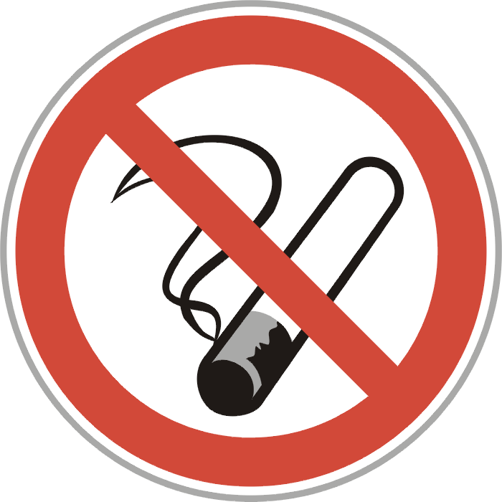
100% Tobacco-Free Child Care
______________________________________________________________________________

Intent Statement
Adults who use tobacco products, and other vapor products and alternative nicotine products (e.g. e-cigarettes) are modeling unhealthy behaviors for children as well as exposing them to an increased risk for health problems, accidental poisoning, and injuries from fires. Infants and young children exposed to secondhand and thirdhand smoke are at an increased risk of developing respiratory illnesses, including allergies and asthma, and infants 0-12 months may be at an increased risk for Sudden Infant Death Syndrome (SIDS). Liquid used in e-cigarettes may be harmful, or even fatal, to children if they get it on their skin, in their eyes or if swallowed. Therefore, for the health, safety, and well-being of children in our care, our facility is 100% tobacco and nicotine-free.

Procedure and Practice
All staff, substitute staff, parents, and volunteers/visitors to this child care facility will be prohibited from using or possessing tobacco products, or using or possessing, vapor products, and alternative nicotine products (as defined in KRS 438.305) at any time;
- Inside the child care facility;
- Outside of the child care facility and anywhere on the facility grounds.
- Inside vehicles parked on the facility grounds;
- Inside child care vehicles used to transport children;
- On field trips with children away from the child care facility.

Education
Developmentally appropriate health and safety education materials regarding the health risks of tobacco use, second and third hand smoke will be used in children’s activities. Staff should also share these educational materials with families whenever possible.

Information to employees about available tobacco cessation counseling and rehabilitation, and any available employee assistance programs will be provided.

Applicable
This policy applies to all staff, substitute staff, parents and volunteers in the child care setting.

Communication
This policy will be reviewed with parents upon application and a summary copy will be included in the parent handbook. This policy will be reviewed with staff upon implementation, at orientation, and annual staff training.

References
American Academy of Pediatrics, American Public Health Association, National Resource Center for Health and Safety in Child Care and Early Education. 2011. Caring for our children: National health and safety performance standards; Guidelines for early care and education programs. 3rd edition. Elk Grove Village, IL: American Academy of Pediatrics; Washington, DC: American Public Health Association. Also available at http://cfoc.nrckids.org/

Division of Regulated Child Care. 922KAR2:120: Child Care Health & Safety Standards http://www.lrc.ky.gov/kar/922/002/120.htm

Kentucky Child Care Health Consultation Program http://kentuckycchc.org

Quit Now Kentucky 1-800-QUIT-NOW and https://www.quitnowkentucky.org/

Kentucky Cancer Link http://kycancerlink.org/prevention/quit-smoking/

Freedom from Smoking Program at your local health department

Reviewed by

Director/Owner
Board Member

CCHC/Health Professional

Staff Member
Parent/Guardian

Effective Date/Review Date
This policy is effective immediately. It will be reviewed yearly by the center director.

