Car Seats: Information for Families from the American Academy of Pediatrics (AAP)
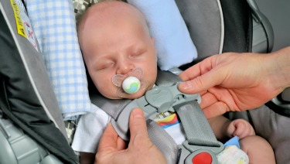

​One of the most important jobs you have as a parent is keeping your child safe when riding in a vehicle. Each year, thousands of young children are killed or injured in car crashes. Proper use of car seats helps keep children safe. But with so many different seats on the market, many parents find this overwhelming.
The type of seat your child needs depends on several things, including your child's age and size and the type of vehicle you have. Read on for more information from the American Academy of Pediatrics (AAP) about choosing the most appropriate car seat for your child.

Types of Car Seats at a Glance:
This chart is a quick guide on where to start your search. It's important to continue your research to learn about each seat you use.
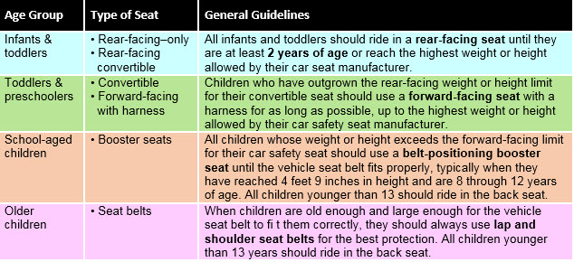

Car Seat Installation Information: Seat Belts & LATCH
Car seats may be installed with either the vehicle's seat belt or LATCH (lower anchors and tethers for children) system.

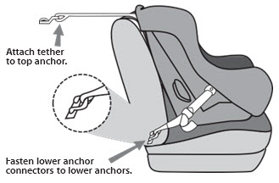
What is LATCH?

LATCH is an attachment system for car seats. Lower anchors can be used instead of the seat belt to install the seat, and many parents find them easier to use in some cars. The top tether improves safety provided by the seat and is important to use for all forward-facing seats, even those installed using the vehicle seat belt. These systems are equally safe, but in some cases it may be easier to install the car seat using one or the other.
Vehicles with the LATCH system have lower anchors located in the back seat, where the seat cushions meet. Tether anchors are located behind the seat, either on the panel behind the seat (in sedans) or back of the seat, ceiling, or floor (in most minivans, SUVs, and hatchbacks). All car seats have attachments that fasten to these anchors. Nearly all passenger vehicles and all car seats made on or after September 1, 2002, are equipped to use LATCH.
All lower anchors are rated for a maximum weight of 65 pounds (total weight includes car seat and child). Parents should check the car seat manufacturer's recommendations for maximum weight a child can be to use lower anchors. New car seats have the maximum weight printed on their label.

If you install a car seat using your vehicle's seat belt:
You must make sure the seat belt locks to help get a tight fit. In most new cars, you can lock the seat belt by pulling it all the way out and then allowing it to retract to keep the seat belt tight around the car seat. Additionally, many car seats have built-in lock-offs to lock the belt without having to lock the seatbelt as well. Refer to the vehicle owner's manual for details about how your seat belt locks.
The safest place to ride for all children younger than 13 years is the back seat. If possible, it may be best to ride in the middle of the back seat. However, it is sometimes difficult to install a car seat tightly in the middle if the vehicle seat is narrow or uneven. Also, most vehicles do not have lower anchors for the middle seating position. It is safest to put the car seat in a position where you can install it tightly with either the lower anchor system or seat belt; in some cases, this may be on either side of the back seat rather than the middle. A child passenger safety technician (CPST) can help you decide which place is best to install your child's car seat in your vehicle.

Rear-Facing Car Seats for Infants & Toddlers
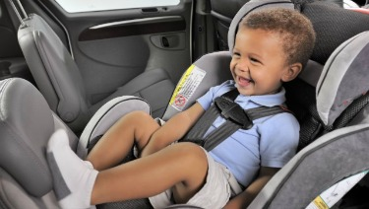
The AAP recommends that all infants ride rear facing starting with their first ride home from the hospital. All infants and toddlers should ride in a rear-facing seat until they are at least 2 years of age or, preferably, until they reach the highest weight or height allowed by their car seat manufacturer.

Types of Rear-Facing Car Seats:
Three types of rear-facing seats are available: rear-facing–only, convertible, and 3-in-1. When children reach the highest weight or length allowed by the manufacturer of their rear-facing–only seat, they should continue to ride rear-facing in a convertible or 3-in-1 seat.

Rear-facing-only seats
- Are used for infants up to 22 to 45 pounds, depending on the model.
- Are small, have carrying handles, and sometimes come as part of a stroller system.
- Usually come with a base that can be left in the car. The seat clicks into and out of the base so you don't have to install it each time you use it. Parents can buy more than one base for additional vehicles.
- Should be used only for travel (not sleeping, feeding, or any other use outside the vehicle).

Convertible seats (used rear facing)
- Can be used rear facing and, later, "converted" to forward-facing for older children when they outgrow the weight limit, the length limit, or both for rear facing. This means the seat can be used longer by your child. They are bulkier than infant seats, however, and do not come with carrying handles or separate bases.
- Many have higher limits in rear-facing weight (up to 40–50 pounds) and height than rear-facing–only seats, which make them ideal for bigger babies and toddlers.
- Have a 5-point harness that attaches at the shoulders, at the hips, and between the legs.
- Should be used only for travel (not sleeping, feeding, or any other use outside the vehicle).

3-in-1 seats (used rear facing)
- Can be used rear facing, forward facing, or as a belt-positioning booster. This means the seat may be used longer by your child as your child grows.
- Are often bigger in size, so it is important to check that they fit in the vehicle while rear facing.
- Do not have the convenience of a carrying handle or separate base; however, they may have higher limits in rear-facing weight (up to 40–50 pounds) and height than rear-facing–only seats, which make them ideal for bigger babies and toddlers.

Installation Tips for Rear-Facing Seats:
*Always read the vehicle owner's manual and the car seat manual before installing the seat.

When using a rear-facing seat, keep the following tips in mind:
- Place the harnesses in your rear-facing seat in slots that are at or below your baby's shoulders.
- Ensure that the harness is snug (you cannot pinch any slack between your fingers when testing the harness straps over the baby's shoulders) and that the retainer clip is placed at the center of the chest, level to your child's armpits.
- Make sure the car seat is installed tightly in the vehicle with either LATCH or a locked seatbelt. If you can move the seat at the belt path more than an inch side to side or front to back, it's not tight enough.
- Never place a rear-facing seat in the front seat of a vehicle that has an active front passenger air bag. If the air bag inflates, it will hit the back of the car seat, right where your baby's head is, and could cause serious injury or death.
- If you are using a convertible or 3-in-1 seat in the rear-facing position, make sure the seat belt or lower anchor webbing is routed through the correct belt path. Check the instructions that came with the car seat to be sure.
- Make sure the seat is at the correct angle so your infant's head does not flop forward. Check the instructions to find out the correct angle for your seat and how to adjust the angle if needed. All rear-facing seats have built-in angle indicators or adjusters.
- Check the car seat instructions and vehicle owner's manual about whether the car seat may contact the back of the vehicle seat in front of it.
- Still having trouble? You may have a certified child passenger safety technician (CPST) in your area who can help. If you need installation help, see the end of this publication for information on how to locate a CPST.
- Watch the video or listen to the audio: How to Install a rear-facing seat https://www.healthychildren.org/English/safety-prevention/on-the-go/Pages/How-to-Install-A-Rear-Facing-Car-Seat-Video.aspx

Common Questions about Rear-Facing Seats:

What if my baby's feet touch the back of the vehicle seat?
- Children can bend their legs easily and will be comfortable in a rear-facing seat. Injuries to the legs are very rare for children facing the rear.

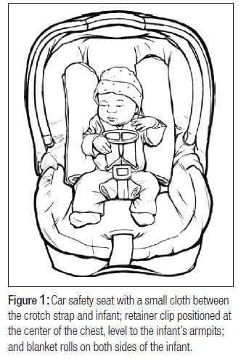

What do I do if my baby slouches down or to the side in the car seat?
- Blanket rolls may be placed on both sides of your infant. A small diaper or blanket may be placed between the crotch strap and your infant too. Do not place padding under or behind your infant or use any sort of car seat insert unless it came with the seat or was made by the manufacturer of the seat. (See Figure 1)

Why should I dress my baby in thinner layers of clothing before strapping him or her into a car seat?
- Bulky clothing, including winter coats and snowsuits, can compress in a crash and leave the straps too loose to restrain your child, leading to increased risk of injury. Ideally, dress your baby in thinner layers and tuck a coat or blanket around your baby over the buckled harness straps if needed. See Winter Car Seat Safety Tips https://www.healthychildren.org/English/safety-prevention/on-the-go/Pages/Winter-Car-Seat-Safety-Tips.aspx

Do preemies need a special car seat?
- A car seat should be approved for a baby's weight. Very small babies who can sit safely in a semi-reclined position usually fit better in rear-facing–only seats. Premature infants should be tested while still in the hospital to make sure they can sit safely in a semi-reclined position. Babies who need to lie flat during travel should ride in a car bed that meets Federal Motor Vehicle Safety Standard 213. They should be tested while in the hospital to make sure they can lie safely in the car bed.

Forward-Facing Car Seats for Toddlers & Preschoolers
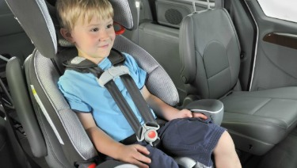
Always read the vehicle owner's manual and the car seat manual before installing the seat. Any child who has outgrown the rear-facing weight or height limit for his convertible seat should use a forward-facing seat with a harness for as long as possible, up to the highest weight or height allowed by his car seat manufacturer. It is best for children to ride in a seat with a harness as long as possible, at least to 4 years of age. If your child outgrows a seat before reaching 4 years of age, consider using a seat with a harness approved for higher weights and heights.

Types of Car Safety Restraints:

Five types of car safety restraints can be used forward facing:
- Convertible seats: Seats can "convert" from rear-facing to forward-facing. These include 3-in-1 seats.
- Forward-facing–only seats: Seats can be used forward facing with a harness for children who weigh up to 40 to 80 pounds (depending on the model). Although manufacturers are not currently making any forward-facing–only seats, many remain in use from previous years.
- Combination seat with harness: Seats can be used forward facing with a harness for children who weigh up to 40 to 90 pounds (depending on the model) or without the harness as a booster (up to 80–120 pounds, depending on the model).
- Built-in seats: Some vehicles come with built-in forward-facing seats. Weight and height limits vary. However, do not use built-in seats until your child is at least 2 years of age. Read your vehicle owner's manual for details about how to use these seats.
- Travel vests: Vests can be worn by children between 20 and 168 pounds and can be an option to traditional forward-facing seats. They are useful for when a vehicle has lap-only seat belts in the rear, for children with certain special needs, or for children whose weight has exceeded that allowed by car seats. These vests may require use of a top tether.

Installation Tips for Forward-Facing Seats:
Always read the vehicle owner's manual and the car seat manual before installing the seat. It is important that the car seat is installed tightly in the vehicle and that the harness fits your child snugly.

To switch a convertible or 3-in-1 seat from rear-facing to forward-facing:
- Move the shoulder straps to the slots that are at or above your child's shoulders. On some convertible seats, the top harness slots must be used when facing forward. Check the instructions that came with the seat to be sure.
- You may have to adjust the reclined angle of the seat so that it sits more upright in your vehicle. Check the instructions to be sure.
- If using a seat belt, make sure it runs through the forward-facing belt path (be sure to follow car seat instructions) and that the seat belt is locked and tightened. If using lower anchors, follow car seat instructions and the vehicle owner's manual.
- Always use the top tether when you can. A tether is a strap that is attached to the top part of a car seat and holds the seat tightly by connecting to an anchor point in your vehicle (often on the seat back or rear shelf; see your vehicle owner's manual to find where tether anchors are in your vehicle). Tethers give important extra protection by keeping the car seat and your child's head from moving too far forward in a crash or sudden stop. All new cars, minivans, and light trucks are required to have tether anchors as of September 2000. Forward-facing seats come with tether straps. A tether should always be used as long as your child has not reached the top weight limit for the tether anchor.
- Check the car seat instructions and vehicle owner's manual for information about the top weight limit and locations of tether anchors.
- Watch the video or listen to audio: How to Install a Forward-Facing Car Seat https://www.healthychildren.org/English/safety-prevention/on-the-go/Pages/How-to-Install-a-Forward-Facing-Car-Seat-Video.aspx

Common Questions about Forward-Facing Seats:

What if I drive more children than can be buckled safely in the back seat?
- It's best to avoid this, especially if your vehicle has air bags in the front seat. All children younger than 13 years should ride in the back seat. If absolutely necessary, a child in a forward-facing seat with a harness may be the best choice to ride in front. Just be sure the vehicle seat is moved as far back away from the dashboard (and air bag) as possible.

What do I need to know if my child will be driven by someone else, such as for child care or school?
- If your child is being driven by someone else, make sure:
  - The car seat your child will be using fits properly in the vehicle used for transport.
  - The car seat being used is appropriate for the age and size of your child.
  - The person in charge of transporting your child knows how to install and use the car seat correctly.
- Child care programs and schools should have written guidelines for transporting children, including:
  - All drivers must have a valid driver's license. In some states, school bus drivers need to have a special type of license.
  - Staff-to-child ratios for transport should meet or exceed those required for the classroom.
  - Every child should be supervised during transport, either by school staff or a parent volunteer, so the driver can focus on driving.
  - School staff, teachers, and drivers should know what do to in an emergency, know how to properly use car seats and seat belts, and be aware of other safety requirements.

Should my child ride in a car seat on an airplane?
- The Federal Aviation Administration (FAA) and the AAP recommend that children less than 40 pounds be securely fastened in certified child restraints when flying. This will help keep them safe during takeoff and landing or in case of turbulence. Most rear-facing, convertible, and forward-facing seats can be used on airplanes, but booster seats and travel vests cannot.
- Look for a label on the car seat that says, "This restraint is certified for use in motor vehicles and aircraft." You can also consider using a restraint made only for use on airplanes and approved by the FAA. Larger children may use the airplane seat belt or continue to use their car seat on the airplane as long as it is labeled for use on aircraft and the child has not exceeded the seat's weight or height limit. Remember that your child will need an appropriate car seat to use at your destination.

Booster Seats for School-Aged Children
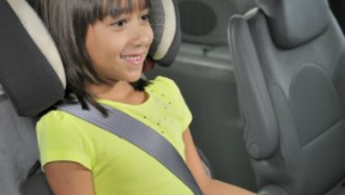Booster seats are for older children who have outgrown their forward-facing seats. All children whose weight or height exceeds the forward-facing limit for their car seat should use a belt-positioning booster seat until the vehicle seat belt fits properly, typically when they have reached 4 feet 9 inches in height and are 8 through 12 years of age. Most children will not fit in most vehicle seatbelts without a booster until 10 to 11 years of age. All children younger than 13 should ride in the back seat.
Instructions that come with your car seat will tell you the height and weight limits for the seat. As a general guideline, a child has outgrown a forward-facing seat when any of the following situations is true:
- He reaches the top weight or height allowed for his seat with a harness. (These limits are listed on the seat and also included in the instruction booklet).
- His shoulders are above the top harness slots.
- His ears have reached the top of the seat.

Types of Booster Seats:
Two types of booster seats are available: high-back and backless. They do not come with harness straps but are used with lap and shoulder seat belts in your vehicle, the same way an adult rides. They are designed to raise a child up so that lap and shoulder seat belts fit properly over the strongest parts of the child's body.
Most booster seats are not secured to the vehicle seat with the seat belt or lower anchor and tether but simply rest on the vehicle seat and are held in place once the seat belt is fastened over a child. However, some models of booster seats can be secured to the vehicle seat and kept in place using the lower anchors or top tether.

Installation Tips for Booster Seats:
When using a booster seat, always read the vehicle owner's manual and the car seat manual before installing the seat. Booster seats often have a plastic clip or guide to correctly position vehicle lap and shoulder belts. See the booster seat instruction booklet for directions on how to use the clip or guide.
Booster seats must be used with a lap and shoulder belt. When using a booster seat, make sure:
- The lap belt lies low and snug across your child's upper thighs.
- The shoulder belt crosses the middle of your child's chest and shoulder and is off the neck.
- Watch the video or listen to the audio : How to Use a Booster Seat https://www.healthychildren.org/English/safety-prevention/on-the-go/Pages/How-to-Use-a-Booster-Seat-Video.aspx
*If your booster seat has lower anchors or top-tether attachments, check its booklet for installation instructions.

Common Questions about Booster Seats:

What if my car has only lap belts in the back seat?
- Lap belts work fine with rear-facing–only, convertible, and forward-facing seats but can never be used with a booster seat. If your car has only lap belts, use a forward-facing seat that has a harness and higher weight limits. You could also:
  - Check to see if shoulder belts can be installed in your vehicle.
  - Use a travel vest (some can be used with lap belts).
  - Consider buying another car with lap and shoulder belts in the back seat.

What is the difference between high-back and backless boosters?
- Both types of boosters are designed to raise your child so seat belts fit properly, and both will reduce your child's risk of injury in a crash. High back boosters should be used in vehicles without head rests or with low seat backs. Many seats that look like high-back boosters are actually combination seats. They come with harnesses that can be used for smaller children and, later, removed for older children. Backless boosters are usually less expensive and are easier to move from one vehicle to another. Backless boosters can be used safely in vehicles with head rests and high seat backs.

Seat Belts for Older Children & Adults
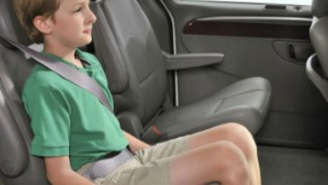
Seat belts are made for adults. Children should stay in a booster seat until adult seat belts fit correctly, typically when children reach about 4 feet 9 inches in height and are 8 through 12 years of age. Most children will not fit in a seat belt alone until 10 to 11 years of age. When children are old enough and large enough to use the vehicle seat belt alone, they should always use lap and shoulder seat belts for the best protection. All children younger than 13 should ride in the back seat.

Using a Seat Belt:

An adult seat belt fits correctly when:
- The shoulder belt lies across the middle of the chest and shoulder, not the neck or throat.
- The lap belt is low and snug across the upper thighs, not the belly.
- Your child is tall enough to sit against the vehicle seat back with her knees bent over the edge of the seat without slouching and can comfortably stay in this position throughout the trip.

Other points to keep in mind when using seat belts include:
- Make sure your child does not tuck the shoulder belt under her arm or behind her back. This leaves the upper body unprotected and adds extra slack to the seat belt system, putting your child at risk of severe injury in a crash or with sudden braking.
- Never allow anyone to "share" seat belts. All passengers must have their own car seats or seat belts.

Common Question about Seat Belts:

I've seen products that say they can help make the seat belt fit better. Should we get one of these?
- No, these products should not be used. They may actually interfere with proper seat belt fit by causing the lap belt to ride too high on the stomach or making the shoulder belt too loose. They can even damage the seat belt. This rule applies to car seats too; do not use extra products unless they came with the seat or are specifically approved by the seat manufacturer. These products are not covered by any federal safety standards, and the AAP does not recommend they be used. As long as children are riding in the correct restraint for their size, they should not need to use additional devices.

Shopping for Car Seats: Tips for Parents

When shopping for a car seat, keep the following tips in mind:
- No one seat is the "best" or "safest." The best seat is the one that fits your child's size, is correctly installed, fits well in your vehicle, and is used properly every time you drive.
- Don't decide by price alone. A higher price does not mean the seat is safer or easier to use.
- Avoid used seats if you don't know the seat's history.
- Watch the video or listen to the audio: What to Look For When Purchasing a Car Seat https://www.healthychildren.org/English/safety-prevention/on-the-go/Pages/What-to-Look-For-When-Purchasing-A-Car-Seat-Video.aspx

Never use a car seat that:
- Is too old. Look on the label for the date it was made. Check with the manufacturer to find out how long it recommends using the seat.
- Has any visible cracks on it.
- Does not have a label with the date of manufacture and model number. Without these, you cannot check to see if the seat has been recalled.
- Does not come with instructions. You need them to know how to use the seat.
- Is missing parts. Used car seats often come without important parts. Check with the manufacturer to make sure you can get the right parts.
- Was recalled. You can find out by calling the manufacturer or contacting the National Highway Traffic Safety Administration (NHTSA) Vehicle Safety Hotline at 888-327-4236. You can also visit the website: https://www-odi.nhtsa.dot.gov/recalls/childseat.cfm
- Do not use seats that have been in a moderate or severe crash. Seats that were in a minor crash may still be safe to use, but some car seat manufacturers recommend replacing the seat after any crash, even a minor one. The NHTSA considers a crash minor if all the following situations are true:
  - The vehicle could be driven away from the crash.
  - The vehicle door closest to the car seat was not damaged.
  - No one in the vehicle was injured.
  - The air bags did not go off.
  - You can't see any damage to the car seat.
- If you are unsure, call the manufacturer of the seat.

About Air Bags
Front air bags are installed in all new cars. When used with seat belts, air bags work well to protect teenagers and adults; however, air bags can be very dangerous to children, particularly those riding in rear-facing seats, and to preschool- and young school–aged children who are not properly restrained. If your vehicle has a front passenger air bag, infants in rear-facing seats must ride in the back seat. Even in a relatively low-speed crash, the air bag can inflate, strike the car seat, and cause serious brain injury and death.
Vehicles with no back seat or a back seat that is not made for passengers are not the best choice for traveling with small children; however, the air bag can be turned off in some of these vehicles if the front seat is needed for a child passenger. See your vehicle owner's manual for more information.
Side air bags are available in most new cars. Side air bags improve safety for adults in side-impact crashes. Read your vehicle owner's manual for more information about the air bags in your vehicle. Read your car seat instructions and the vehicle owner's manual for guidance on placing the seat next to a side air bag.

If You Need Installation Help:
If you have questions or need help installing your car seat, find a certified passenger safety technician (CPST). Try calling your local fire department or your local Safe Kids Coalition. In Lexington, Kentucky, call Safe Kids Fayette County to make an appointment for their next car seat fitting station event (859-323-1153).

PLEASE!
- Be a good role model. Make sure you always wear your seat belt. This will help your child form a lifelong habit of buckling up.

- Make sure that everyone who transports your child uses the correct car seat or seat belt on every trip, every time. Being consistent with car seat use is good parenting, reduces fussing and complaints, and is safest for your child.

- Never ever leave your child alone in or around cars. Any of the following situations can happen when a child is left alone in or around a vehicle. A child can:
- Die of heat stroke because temperatures can reach deadly levels in minutes.
- Be strangled by power windows, retracting seat belts, sunroofs, or accessories.
- Knock the vehicle into gear, setting it into motion.
- Be backed over when the vehicle backs up.
- Become trapped in the trunk of the vehicle.

- Always read and follow the manufacturer's instructions for your car seat. If you do not have those, write or call the company's customer service department. They will ask you for the model number, name of seat, and date of manufacture. The manufacturer's address and phone number are on a label on the seat. Also, be sure to follow the instructions in your vehicle owner's manual about using car seats. Some manufacturers' instructions may be available on their Web sites.

*IMPORTANT SAFETY INFORMATION: Infants should only be in their car seats when traveling in cars. Always remove an infant from the car seat when not traveling in the car. A car seat should never be used as a substitute for a safety approved sleep space, such as a crib.

Additional Information from HealthyChildren.org for the following and more: https://www.healthychildren.org/English/Pages/default.aspx
- Car Seats: Product Listing
- Car Seat Checkup
- Car Seats and Obese Children: Suggestions for Parents
- Prevent Child Deaths in Hot Cars​
Although the AAP is not a testing or standard-setting organization, this article sets forth the AAP recommendations based on the peer-reviewed literature available at the time of its publication and sets forth some of the factors that parents should consider before selecting and using a car seat.
Listing of resources does not imply an endorsement by the AAP. The AAP is not responsible for the content of external resources. Information was current at the time of publication.
The information contained in this article should not be used as a substitute for the medical care and advice of your pediatrician. There may be variations in treatment that your pediatrician may recommend based on individual facts and circumstances
LATCH image adapted from National Highway Traffic Safety Administration. LATCH Makes Child Safety Seat Installation as Easy as 1-2-3. 2011. DOT HS publication 809 489. Published March 2011. Accessed November 5, 2015.
Figure 1 from Bull MJ, Engle WA; American Academy of Pediatrics Committee on Injury, Violence, and Poison Prevention, Committee on Fetus and Newborn. Safe transportation of preterm and low birth weight infants at hospital discharge. Pediatrics. 2009; 123 (5); 1424–1429.

Source:
Car Safety Seats: A Guide for Families 2016 (Copyright © 2016 American Academy of Pediatrics)
The information contained on this website should not be used as a substitute for the medical care and advice of your pediatrician. There may be variations in treatment that your pediatrician may recommend based on individual facts and circumstances.
https://www.healthychildren.org/English/safety-prevention/on-the-go/Pages/Car-Safety-Seats-Information-for-Families.aspx

Last Updated 2/18/2016

