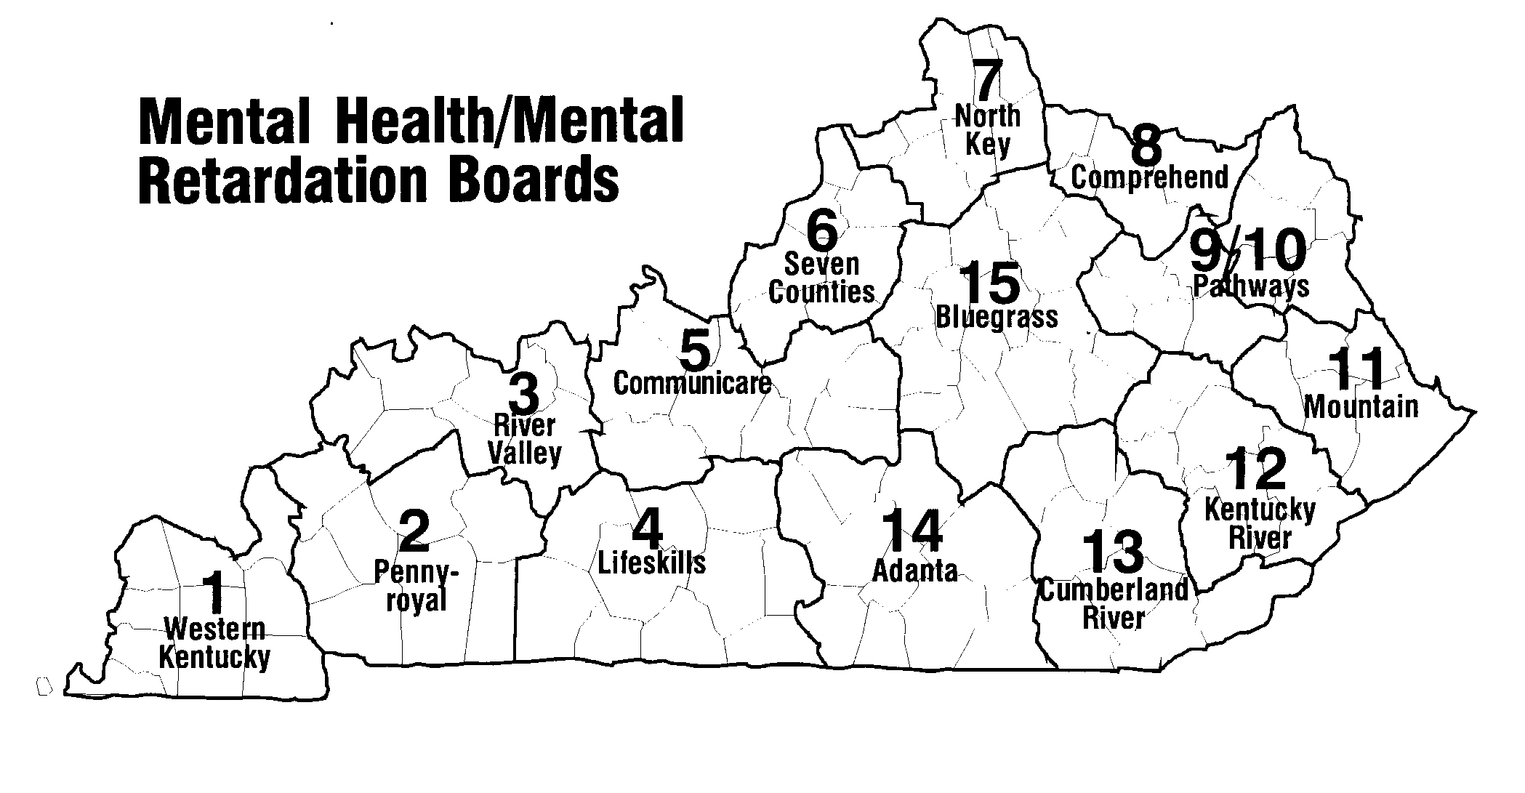
Region # | Region | Counties Served | Name | Contact Info.
1 | Four Rivers Behavioral Health | Fulton, Hickman, Carlisle, Ballard, McCracken, Graves, Livingston, Marshall, Calloway | Ashley Gupton  Supervisor:  Gretchen Roof | Four Rivers Behavioral Health  CSCS  425 Broadway  Paducah KY 42001  Phone: 270-442-7121  Fax: 270-442-7923  Email: groof@4rbh.org  Ashley Gupton  (270) 442-9767 Work  (270) 442-7923 Fax  agupton@4rbh.org
2 | Pennyroyal | Crittenden, Lyon, Caldwell, Trigg, Christian, Hopkins, Muhlenberg, Todd | Dianne Glasscock  Supervisor:  David Ptaszek | Pennyroyal Center  735 North Drive  Hopkinsville, KY 42241  Phone: 270-886-5186  Fax: (270) 886-0393  Email:dhglasscock@pennyroyalcenter.org
3 | River Valley | Union, Webster, Henderson, Daviess, McLean, Ohio, Hancock | April Bishop  Supervisor:  Mary Kay Lamb | River Valley Behavioral Health  P.O. Box 1637  1100 Walnut Street  Owensboro, Ky 42302-1637  Phone - 270-689-6591  Work Cell: 270-570-2396  Fax - 270-689-6677  Email: aprilbishop@rvbh.com
4 | LifeSkills | Allen, Barren, Butler, Edmonson, Hart, Logan, Metcalf, Monroe,  Simpson, Warren | Sandy Hackbarth  Supervisor:  Robin Gregory | LifeSkills, Inc.  380 Suwannee Trail  Bowling Green, KY 42103  Phone: 270-901-5000 X 1008  Fax: 270 782-5927  Email: Cblack@lifeskills.com

5 | Communicare | Breckinridge, Grayson, Meade, Hardin, Nelson, LaRue, Washington, Marion | Brittany Rigney  Supervisor:  Shelley Fentress | Communicare Inc.  100 Gray St.  Elizabethtown, KY 42701  Work: (270) 769-1304 ext. 1119  Fax: (270)-234-8028  BRigney@communicare.org  sgreenwell@communicare.org
6 | Seven Counties | Jefferson, Bullitt, Spencer, Shelby, Oldham, Henry, Trimble | Darcie Taggart  Supervisor:  David Weathersby | Seven Counties Services, Inc.  Family Connections  914 E. Broadway, 2nd Floor  Louisville, KY 40204  Phone: 502-589-8731  Fax: 502-589-8097  Email: DTaggart@sevencounties.org
7 | NorthKey | Boone, Kenton, Campbell, Carroll, Owen, Gallatin, Grant, Pendleton | Rachel Smith  Tiffany Staggs  Supervisor:  Sandra George | NorthKey Community Care  722 Scott St.  Covington, KY 41011  Phone: (859) 491-1348  Fax: (859) 491-7174  Email:  rachel.smith@northkey.org  tiffany.staggs@northkey.org  sgeorge@northkey.org
8 | Comprehend | Bracken, Robertson, Mason, Fleming, Lewis | Maria Anderson  Morgan Frodge  Supervisor:  Goldie Williams | Comprehend, Inc.  611 Forest Avenue  Maysville, KY 41056  Phone: 606-564-4016  Fax: 606-564-8288 or 4043  Email: manderson@comprehendinc.org  mfrodge@comprehendinc.org  gwilliams@comprehendinc.org
9/10 | Pathways (FIVCO) | Bath, Boyd, Carter,  Elliot , Greenup, Lawrence, Montgomery, Rowan, Menifee, Morgan | Marci McDaniels  Supervisor:  Heather Compton | Pathways, Inc.  PO Box 790  Ashland, KY 41101  Phone: 606-324-3005 x 4182  Fax: 606-329-1530  Email: Marci.mcdaniels@pathways-ky.org
11 | Mountain | Magoffin, Johnson, Martin, Floyd  Pike | Kristal Jenkins  Nathan Ratcliff  Supervisor:  Robin Gray | Mountain CCC  150 S. Front Ave.  Prestonsburg, KY 41653  Work: 606-866-4350  Fax: 606-437-5412  E-mail:kjenkins@mtcomp.org Nathan.ratcliff@mtcomp.org  606-432-3143

12 | Kentucky River | Perry, Knott, Letcher, Leslie  Wolfe, Lee, Owsley, Breathitt | Joann Hurt  Supervisor: Renee Roberts | Joann Hurt  KRCC  115 Rockwood Lane  Hazard KY 41701  Work: 606-436-5761 x 7210  Email: jo.hurt@krccnet.com
13 | Cumberland River | Rockcastle, Jackson, Laurel, Clay, Knox, Whitley, Bell, Harlan | Kathy Duvall  Supervisor:  Jill West | Mailing address:  Cumberland River Comp. Care Center  P.O. Box 568  Corbin, KY 40702-0568  Physical address:  CAPERS  197 Peachtree Street  Corbin, KY 40701  Work: 606-526-9459 ext 180  Fax: 606-526-0723  Email: kduvall@crccc.net
14 | Adanta | Green, Taylor, Adair, Russell, Cumberland, Casey, Pulaski, Clinton, Wayne, McCreary | Jodi Martin  Supervisor:  Beverly Loy | Adanta  200 East Frazier Ave.  Columbia, KY 42728  Phone number: 270-384-2499  Fax: 270-384-4820  Email address: jmartin@adanta.org
15 | Bluegrass | Franklin, Anderson, Woodford, Scott, Harrison, Bourbon, Nicholas, Fayette, Jessamine, Clark, Powell, Mercer, Boyle, Lincoln, Garrard, Madison, Estill | Stephanie Adamkin  Supervisor:  Chris Whitsell | Bluegrass Regional MH/MR Board, Inc.  1351 Newtown Pike  Building 5  Lexington, KY  Phone: 859-254-3106 ext 2235  Cell: 859-806-9231  Fax: 859-253-1177  Email: smadamkin@bluegrass.org

