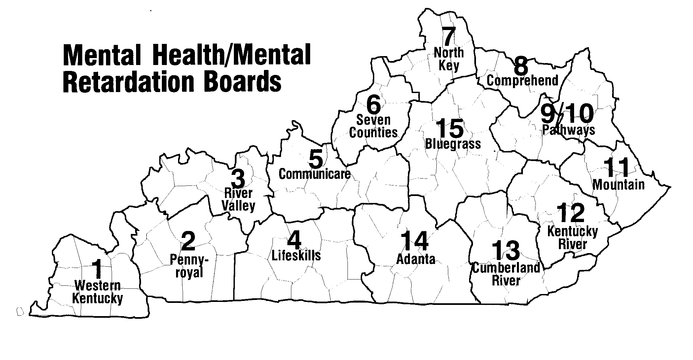
Region # | Region | Counties Served | Name | Contact Info.
1 | Four Rivers Behavioral Health | Fulton, Hickman, Carlisle, Ballard, McCracken, Graves, Livingston, Marshall, Calloway | Ashlee Brockwell  Supervisor:  Gretchen Roof | Four Rivers Behavioral Health, CSCS  425 Broadway  Paducah KY 42001  (270) 442-9767 Work  (270) 442-7923 Fax  agupton@4rbh.org  Gretchen Roof  Phone: 270-442-7121 or 270-442-9767  Fax: 270-442-7923  groof@4rbh.org
2 | Pennyroyal | Crittenden, Lyon, Caldwell, Trigg, Christian, Hopkins, Muhlenberg, Todd | Dianne Glasscock  Supervisor:  Lacey Folz | Pennyroyal Center  400 Hammond Plaza  Hopkinsville, KY 42240  Phone: 270-886-5186  Fax: (270) 886-0393  dhglasscock@pennyroyalcenter.org  Lacey Folz  Phone: 270 886-5163 ext. 277  Email: lfolz@pennyroyalcenter.org
3 | River Valley | Union, Webster, Henderson, Daviess, McLean, Ohio, Hancock | Dana Sandifer  Supervisor:  Leslie Bentley  Mary Kay Lamb | River Valley Behavioral Health  P.O. Box 1637  1100 Walnut Street  Owensboro, Ky 42302-1637  Office- (270)689-6885  Cell- (270)570-2385  Sandifer-Dana@rvbh.com
4 | LifeSkills | Allen, Barren, Butler, Edmonson, Hart, Logan, Metcalf, Monroe,  Simpson, Warren | Sandy Hackbarth  Supervisor:  Robin Gregory | LifeSkills, Inc.  380 Suwannee Trail  Bowling Green, KY 42103  Phone: 270-901-5000 X 1008  Fax: 270 782-5927  Cblack@lifeskills.com
Region # | Region | Counties Served | Name | Contact Info.
5 | Communicare | Breckinridge, Grayson, Meade, Hardin, Nelson, LaRue, Washington, Marion | Jessica Cooper  Supervisor:  Racquel Strickland | Communicare, Services  100 Gray St.  Elizabethtown, KY 42701  Work: (270) 769-1304 ext. 1118  Fax: (270) 982-9209  Email:  JCooper@communicare.org  RStrickland@communicare.org
6 | Centerstone Kentucky | Jefferson, Bullitt, Spencer, Shelby, Oldham, Henry, Trimble | Darcie Taggart  Supervisor:  David Weathersby | Centerstone Kentucky  Family Connections  914 E. Broadway, 2nd Floor  Louisville, KY 40204  Phone: 502-589-8731  Fax: 502-589-8097  darcie.taggart@centerstone.org
7 | NorthKey | Boone, Kenton, Campbell, Carroll, Owen, Gallatin, Grant, Pendleton | Chelsey Derifield  Whitney Cundiff  Supervisor:  Sandra George | NorthKey Community Care  722 Scott St.  Covington, KY 41011  Phone: (859) 491-1348  Fax: (859) 491-7174  c.derifield@northkey.org  whitney.cundiff@northkey.org  sgeorge@northkey.org
8 | Comprehend | Bracken, Robertson, Mason, Fleming, Lewis | Maria Anderson  Morgan Frodge  Supervisor:  Goldie Williams | Comprehend, Inc.  611 Forest Avenue  Maysville, KY 41056  Phone: 606-564-4016  Fax: 606-564-8288 or 4043  manderson@comprehendinc.org  mfrodge@comprehendinc.org  Goldie Williams  gwilliams@comprehendinc.org
9 | Pathways  Gateway | Bath, Montgomery, Menifee, Morgan, Rowan | Carolyn Sie Powell  Supervisor:  Heather Compton | Pathways, Inc.  300 Foxglove Drive  Mount Sterling, KY 40353  Phone: 859-498-2135 x 4240  Fax: 606-329-1530  Sie.powell@pathways-ky.org  Heather Compton hcompton@pathways-ky.org
10 | Pathways FIVCO | Boyd, Carter,  Elliot, Greenup, Lawrence, | Sonja Gamble  Supervisor:  Heather Compton | Pathways, Inc.  PO Box 790  Ashland, KY 41101  Phone: 606-324-3005 x 4198  Fax: 606-329-1530  Sonja.Gamble@pathways-ky.org  Heather Compton hcompton@pathways-ky.org
Region # | Region | Counties Served | Name | Contact Info.
11 | Mountain | Magoffin, Johnson, Martin, Floyd  Pike | Kristal Jenkins  Nathan Ratliff  Supervisor: | Mountain CCC  150 S. Front Ave.  Prestonsburg, KY 41653  Work: 606-866-4350  Fax: 606-437-5412  kjenkins@mtcomp.org  nathan.ratliff@mtcomp.org  606-432-3143
12 | Kentucky River | Perry, Knott, Letcher, Leslie, Wolfe, Lee, Owsley, Breathitt | Terrah Combs  Supervisor: Amber Maggard | Terrah D. Combs M.Ed., LPCC  Kentucky River Community Care  115 Rockwood Lane  Hazard, KY 41701  606-436-5761 ext. 7322  Fax: 606-436-2467  terrah.combs@krccnet.com
13 | Cumberland River | Rockcastle, Jackson, Laurel, Clay, Knox, Whitley, Bell, Harlan | Kathy Duvall  Supervisor:  Jill West | Mailing address:  Cumberland River Behavioral Health, Inc.  P.O. Box 568  Corbin, KY 40702-0568  Work: 606-526-9459 ext. 120  Fax: 606-526-0723  kathy.duvall@crccc.org  Physical address:  CAPERS  175 E. Peachtree Street  Corbin, KY 40701
14 | Adanta | Green, Taylor, Adair, Russell, Cumberland, Casey, Pulaski, Clinton, Wayne, McCreary | Jodi Martin  Supervisor:  Patti Page &  Beverly Loy | Adanta  200 East Frazier Ave.  Columbia, KY 42728  Phone: 270-384-3898 or 270-384-1746  Fax: 270-384-4820  jmartin@adanta.org
15 | Bluegrass | Franklin, Anderson, Woodford, Scott, Harrison, Bourbon, Nicholas, Fayette, Jessamine, Clark, Powell, Mercer, Boyle, Lincoln, Garrard, Madison, Estill | (Vacant mid-June)  Supervisor:  Nina Begley | Bluegrass.org  1351 Newtown Pike, BLDG 5  Lexington, KY 40511  Fax: 859-268-8888  Cell: 859-806-9231  Email: vacant  Nina L. Begley, MBA, MS, LPP  1351 Newtown Pike, Building 3 Lexington, KY 40511-1277  Phone 859.455.7452 x 227  Email: nlbegley@bluegrass.org

